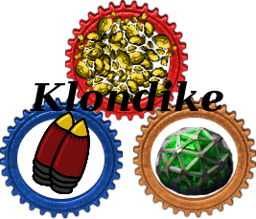

Klondike
Design by Rasmusen Sven, Monir Lennart, Hoff Marvin
For Microsoft Windows, macOS and Linux
Rating: E12+

Table of Contents
Mod story: 3
Mod impact: 3
New features: 4
Gold: 4
Goldstatue: 5
Fast processor: 5
Gold wire: 6
Jetpack: 7
DefBot: 8
Nuke extension: 8
Fishbait: 8
Greenhouse and plants: 9
Soysauce: 9
Rice: 10
Salt: 10
Stealthsushi: 10
Hunger: 11
Better Solarpanels: 12
Gravel: 12
Sand: 13
Glas: 13
Mill: 13
New poisoncapsule: 14
New item drops: 14
Kitchen and food: 15

Mod story:
You are set into the unexplored vast world of Factorio. Yet now you notice there is something different to the world you know. You explore your newly created map and discover several new and different craftable items. And encounter a new and shiny resource, Gold! After a while of exploring your extended universe, you experience an empty feeling in your stomach. Yes! You can now starve to death.

Mod impact:
Playing Factorio, one instantly notices all the details the developers have put in the game, but there are some little flaws and gaps waiting to be filled. Installing Klondike will extend your gameplay by adding new craftable items such as, fast processors, jetpacks, a fellow combat ready defensive robot, a more realistic nuke, a greenhouse and more. With these new craftable items, the player can now make use of some material in the game that hasn't been found useful before, for example fish can now be used to create bait. Furthermore we added a new and rare resource, gold! Gold will be used to create most of these new craftable items, making them harder to get but therefore very rewarding! Our goal with this mod is to enable the players to craft equipment to get stubborn tasks done quicker and easier, but the equipment should not come cheap! We want the requirements for the equipment to be hard to get, so that when the players craft the items, they experience a sense of accomplishment. Carrying on, we also wanted to make the game a little tougher, forcing the player to be more prepared before they head out of their base.

New features:

Gold:

There aren't too many different resources in Factorio and one resource found in many sandbox games but sadly not in Factorio is gold. We plan on adding gold in for a very good reason! We want the player to be able to look for another more valuable and rare resource. Gold can then be used to create new and more rewarding equipment. On the other hand, we will have gold appear seldom, for the very reason to make the products out of gold less gamebreaking. Farming gold will also be a bit timeconsuming, first one recieves the gold nuggets. Then to create one gold bar you need to combine five gold nuggets. Adding on to that, before you the a gold bar, you must first attempt to filter it out of the gold nuggets with a furnance.

Goldstatue:

Now that we have the new resource, gold, we can add some new objects that require gold. To spice things up in the game we are adding a goldstatue, allowing the player decorate their base with a mighty shiny goldstatue! To create a statue a bit of stone, some gold bars and gold nuggets will be required.

Fast processor:

Processors in Factorio are used for almost every automated machine. We wanted to add on another and more powerful processor which, ofcourse, requires gold and a weaker processor to be made. The processor can then be used to create even more equipment. This chain reaction of requiring newer and newer resources is all on planned to make the game more rewarding.

Gold wire:

Gold wire will be used to make the creation of fast processors more realistic, adding an entire gold bar to a lesser processor just doesn't seem right. Therefore, we will have the recipe be one gold bar turns into 10 gold wire.

Jetpack:

source: “http://clubpenguin.wikia.com”
The, in our opinion, most exciting part in our mod! After playing on your Factorio map for a few hours you will notice one of the most annoying tasks is to just move around in your base, because everything is filled with buildings and conveyor belts. A jetpack will finally end the endless walking around in zigzag motions. The recipe for a jetpack can't be an easy one, otherwise the jetpack wouldn't be a goal to reach. Furthermore, the player will have to research the jetpack technology in the Lab, a building within the game that is used to discover new technologies. Using the jetpack will also burn through a lot of fuel so that you can't just fly around as much as you want.

DefBot:
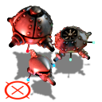
Having a friendly companion that has your back when going out on dangerous adventures is a must! Although Factorio has a defensive bot, attack bot and a distraction bot, they just don't quite hit the mark when it comes to them being a companion, because they self-destruct after a short time. We introduce you to the DefBot. He will be a combination of all three previous bots, but he will stick to you for 10 Minutes, which is a lot better than 30 seconds. Ingredients to create this loyal friend will be the 3 previous bots, a new batterie and our newly added fast processor.
source: Factorio files

Nuke extension:

The nuke in Factorio is the most powerful weapon, but after launching a nuke, there is no sign of radiation or any other kind of drawback. We will modify the nuke so that the player can now add some poison capsules to the nuke and after launching one, there will be a big cloud of poison. The goal is to then force the enemy units to go through the poison, leaving only a handful left to kill.

Fishbait:
Fish is found in the unmodified version of Factorio, but is has absolutely no use. We wanted to give the fish some purpose and are adding in fishbait. With 10 fish you can create 1 fishbait, which then can be used to temporarily distract the enemies.

Greenhouse and plants:
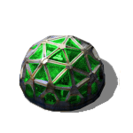
We wanted to add in a touch of chemistry and a chemistry like feeling to the game, so we came up with the greenhouse. A greenhouse will need water supply and electricity to be able to grow some new plants. Plants that we have added in are:
  - Soybean plant
  - Rice plant
  - Grain
  - Mushroom
And we also added in fertilizer the player would then have to put into the greenhouse aswell to grow the plants.

Soysauce:
As mentioned above, we can acquire soybeans from the greenhouse. These soybeans can then be fermented in the chemistry lab, which is already in the game, to create soy sauce. The chemistry lab would also need water and salt to be able to ferment the soybeans.

Rice:
In Addition, the greenhouse can also create rice. Which then can be used to make the stealthsushi. Just like the soy sauce, the greenhouse will need water and electricity to create the rice, the player just has to always select the plant they desire from the greenhouse.

Salt:

Salt is going to be a simple and easy to obtain item in the game. A chemistry lab will receive water and out comes the salt. Salt is there to add another ingredient to other recipes and therefore shouldn't be hard to get.

Stealthsushi:

Source: “http://www.sushiexpress.lt”
Here is another very exciting part in our mod, the stealthsushi! Going on a long haul in the game with ammunition and killing enemies can be fun, but what about just eating a modified sushi to turn yourself invisible and get past the enemy borders with ease. Or when you run out of ammunition you may need to escape, well grab a bite of that sushi! Since being invisible is a big advantage and you will only need fish and soysauce to create it, the stealthsushi will only grant a short period of time of invisibility, otherwise it would break the game and players will only run around invisible.

Hunger:

Hunger in a game can be very annoying, but in a survival game it can make it more challenging in a fun way. You can't just go out with big guns and a bunch of ammunition anymore, now you will need to bring some food with you and more of your awareness, because if you don't pay attention to your hunger, then your walking speed slows down by around 50%. The useless fish now really isn't that useless anymore, with the new recipes and now also hunger, player will have to spend time fishing, which otherwise didn't make any sense in the unmodified verison of Factorio.

While we were testing the hunger bar, we were thinking about how the hunger should decrease in the best way possible. From constant depletion to multiple random algorithms, we finally came up with a good algorithm that has a maximum limit and a minimum limit. The algorithm mainly computes the difference between the current hunger level and the maximum hunger level and the greater the difference the faster the hunger bar depletes. This means that if the player does not take care of his hunger bar then it will decrease gradually faster to a certain minimum speed.

Here is a graph of how the hunger bar gradually speeds up on depleting.
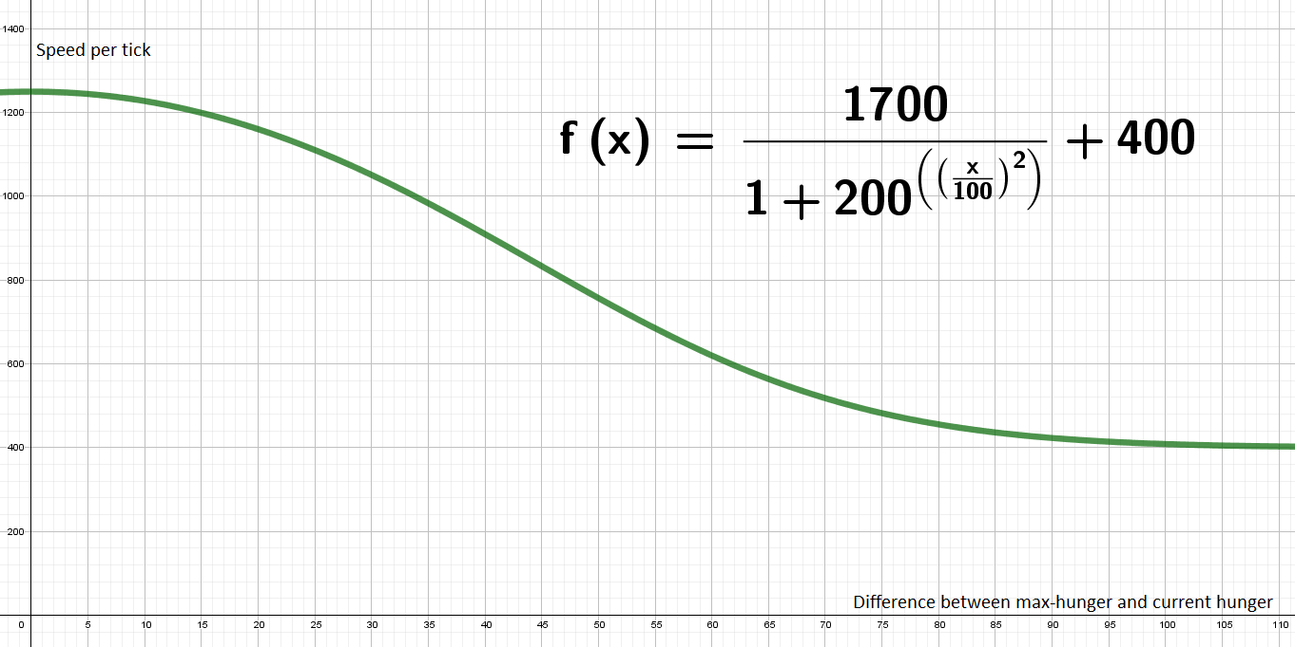

Better Solarpanels:
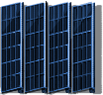
We wanted to create more use for sand and the fast processor, which is why we added in new and more powerful solarpanels. Sand will be put in to the furnance and be turned into glas, afterwards the player can combine glas, fast processor and the default solarpanels to create the better solarpanels.


Gravel:
Gravel is a new ressource that derives from stone with the help of a mill. Gravel will also be used to gain gold in a assamblingmashine.


Sand:
Just like Gravel, sand is a new ressource which can be obtained by feeding a mill with gravel. Sand will have to be added in the assamblingmashine next to gravel and water to receive gold. The player will also be able to craft the newly added better Solarpanels with the help of sand.

Glas:

Having put in glas into the game gives sand more purpose and makes creating certain items more realistic, for instance crafting better solarpanels requires better glas. The player would only have to put in the sand into the furnance and then receives glas.

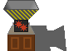
Mill:

We added in another inbetween step for creating new ressources and making gold a little more laborious to get. The mill will take in Stone to create the new ressources gravel and sand. The player will either receive gravel or sand.


New poisoncapsule:

Once again, we wanted to make the game more realistic and added a little bit more chemistry to the game, by changing the default recipe for poisoncapsules and forcing the player to use our salt and turn it into chlorine gas, which then can be used to create a poisoncapsule.

New item drops:


Since we made the game harder with the hunger bar, we also have to create ways for the player to be able to find food. We therefor gave various object in the environment the chance to drop eatable items, such as:
  - Apple, drops from trees


  - Mushroom and Seed, drops from enemy bases

  - Raw meat, drops from enemy aliens

Kitchen and food:
Because we implemented the new hunger mechanic, we now have to provide the player with ways to fill up their hunger bar. We are therefor introducing multiple new foods:

  - Cooked meat


  - Apple pie


  - Schnitzel


  - Pizza


  - Tofu


  - Bread


  - Flour


  - Cooked Rice

  - Ham

  - Soup
And for the user to be able to craft these newly added foods, we also brought in a kitchen. There are two types of kitchen, the coal kitchen and the electric kitchen. The main difference between these two types of kitchens is that the electric kitchen cooks faster and produces less pollution



- Coal kitchen - Electric kitchen

